Test Case Examples for Views

Requirement to test | Test Data Input | Expected Outcomes | Actual Outcomes
- Interface displayed correctly when the program runs | Run Program | 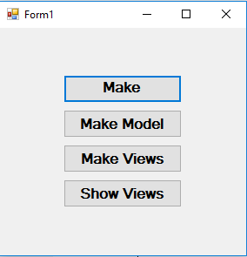 | As expected
- Show views | Click the four buttons from top to bottom | View1, view2, view3 show correctly | As expected
- Test show view1 | Run Program and show all the views | View1 shows correctly  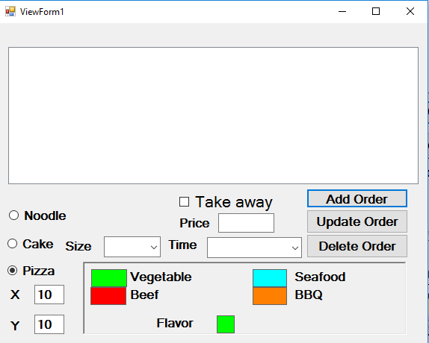 | As expected
- Add an object | Select noodle | 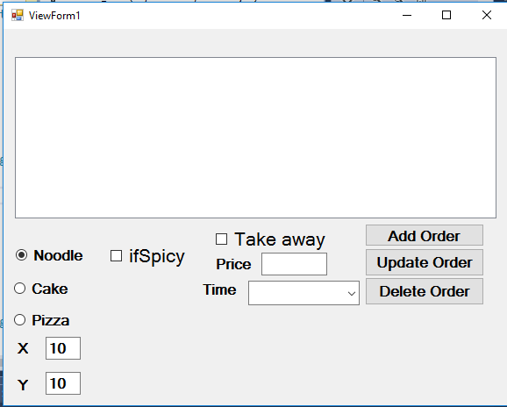 | As expected
 | Set the attributes | 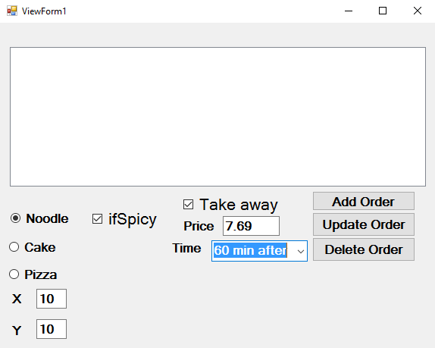 | As expected
 | Click “Add Order” | 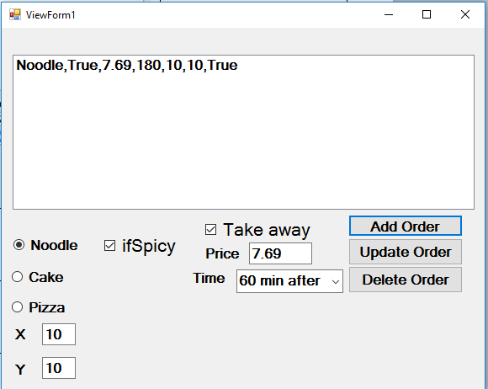 | As expected
- Modify an object | Run the program and add four objects | 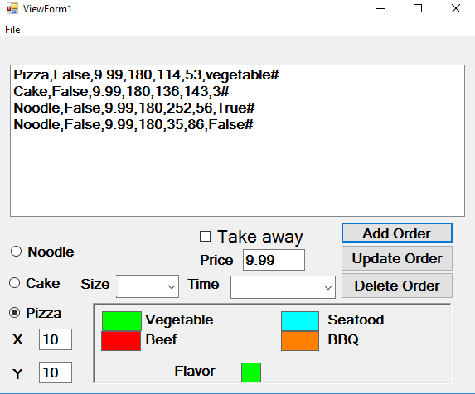 | As expected
 | Select the 3rd objects | 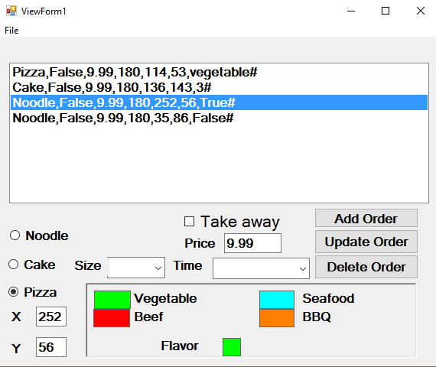 | As expected
 | Change its x and y value to new values, then click “update order” | 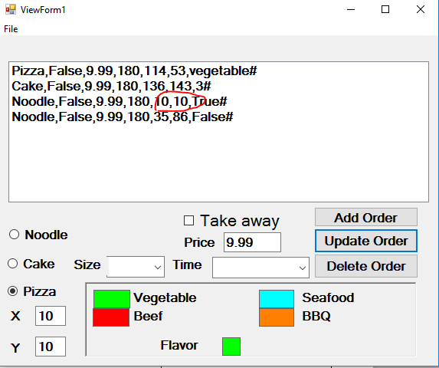 | As expected
- Delete an object | Run the program and add four objects |  | As expected
 | Select the 3rd objects |  | As expected
 | Click “Delete Order” | 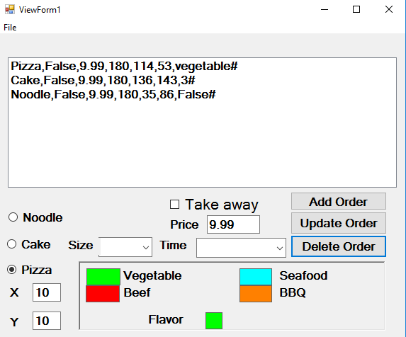 | As expected
- Test show view2 | Run Program and show all the views | View2 shows correctly  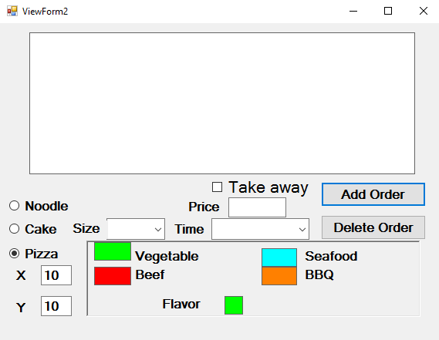 | As expected
- Add an object | Select cake | 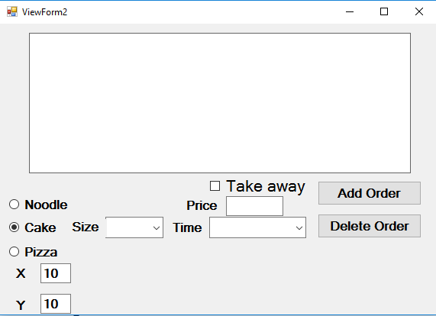 | As expected
 | Set the attributes | 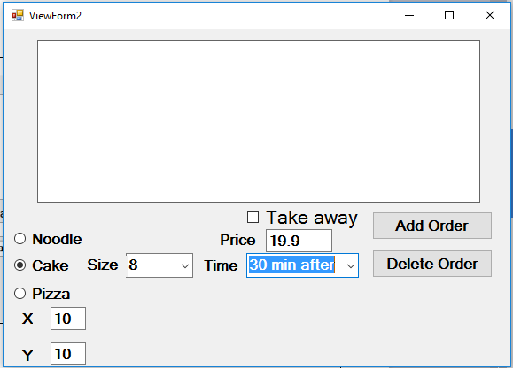 | As expected
 | Click “Add Order” | 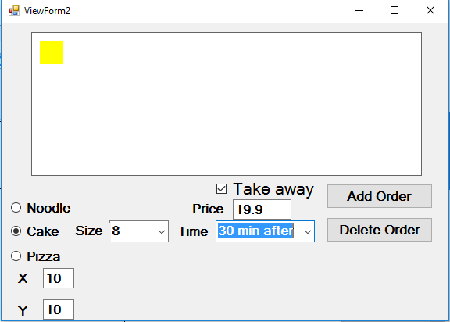 | As expected
- Modify an object | Run the program and add four objects | 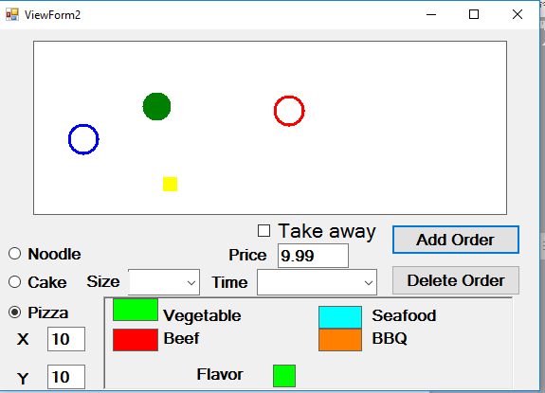 | As expected
 | Select one of the objects, drag it to another position and drop it. | 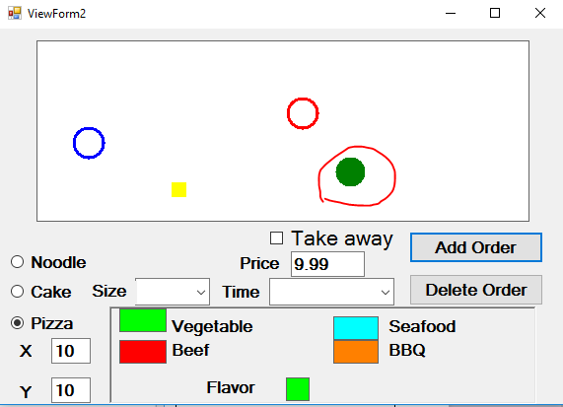 | As expected
- Delete an object | Run the program and add four objects | 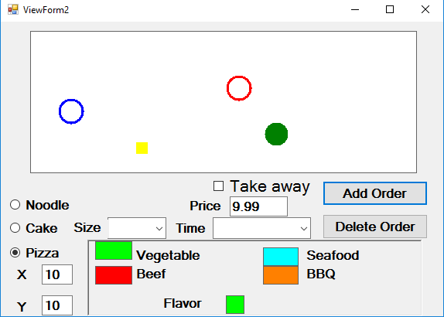 | As expected
 | Select one of the objects | 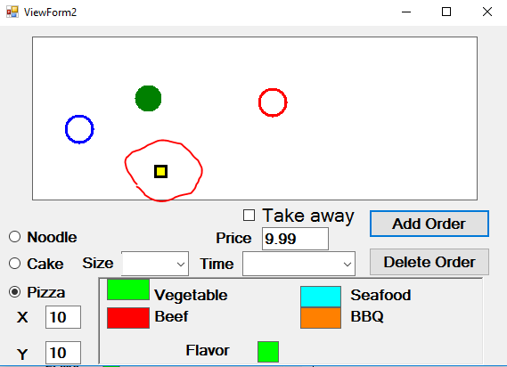 | As expected
 | Click “Delete Order” | 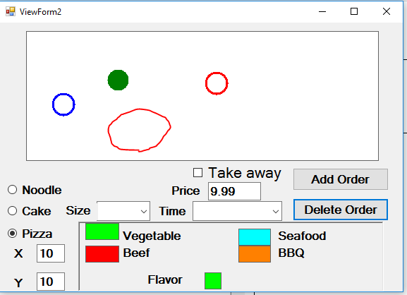 | As expected
- Test show view3 | Run Program and show all the views | View3 shows correctly  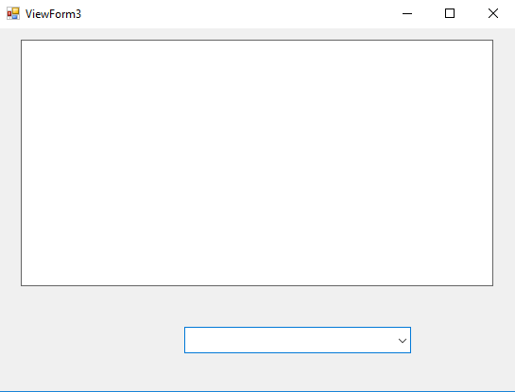 | As expected
 | Add 4 orders through view1 or view2 | View3 shows the orders correctly  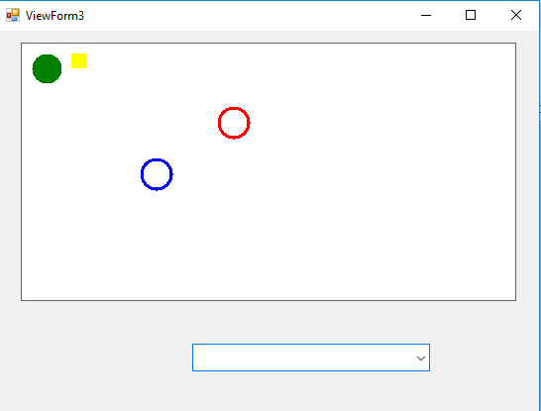 | As expected
- Test read only | Drag the shapes on the panel | The shapes are read only, can’t be moved | As expected
- Test filter | Select “noodle only” in the selector | Only the circles show, other shapes are hidden.  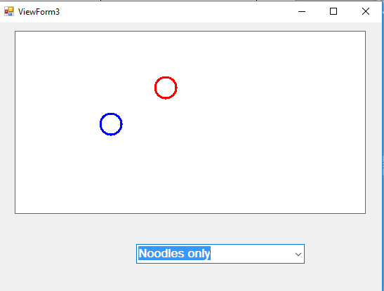 | As expected

